|  |
| --- |
| Ralph Allen School |
| User Documentation |
| 3006 - 50723 |

|  |
| --- |
| Nick Appleton  2-25-2016 |

Contents

System Instalation 2

Requirements 4

Hardware 4

Software 4

Using the System 5

Starting the Game 5

Playing the Sidescroller 6

Controlling the Airship 6

Aim of the Game 6

Losing Health 7

Defending your Cockpit 7

Retuning the Engines 8

Level Progression 8

Losing the Game and Scoring 9

Troubleshooting 10

Download and Installation Problems 10

Game Problems 11

Glossary 12

# System Instalation

First you must install python and pygame. To do this you must go to their respective websites.

To install python, Open your browser and go to <https://www.python.org/downloads/> it should look like this:

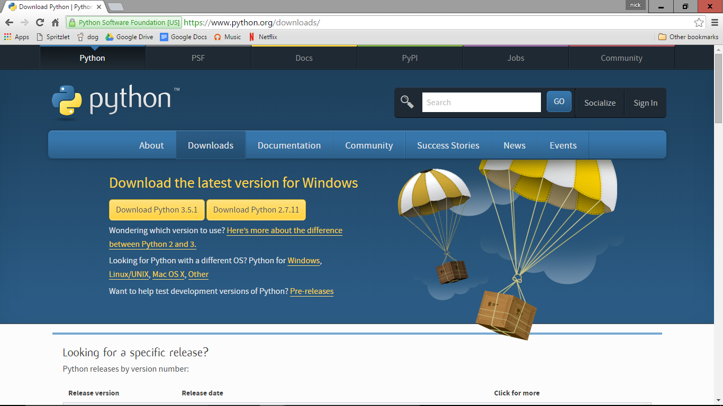

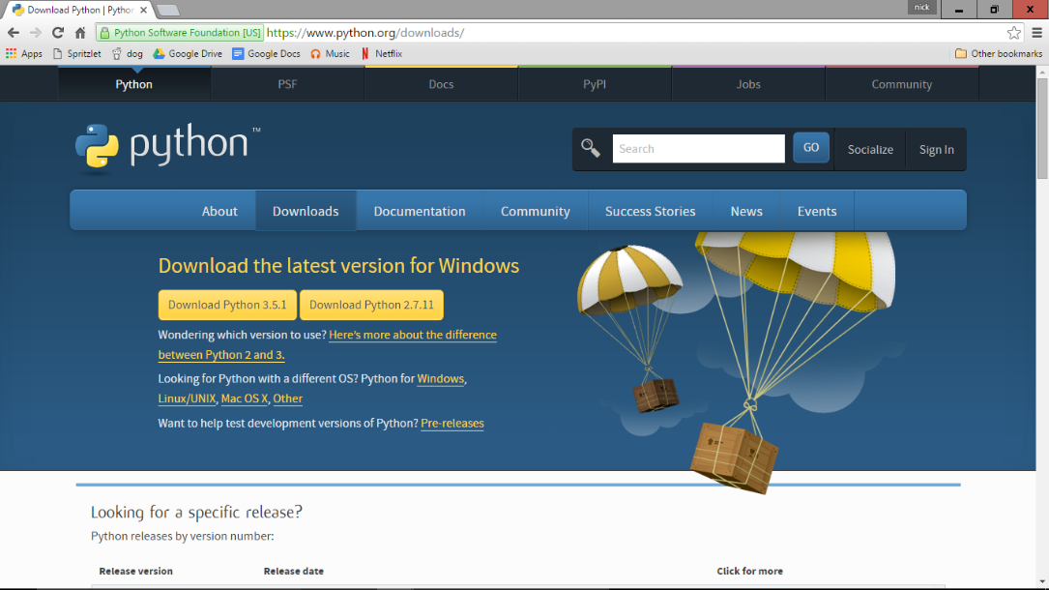To run this game, you will need to download and install Python 3.1.5. To do this, click the “Download Python 3.1.5”. If you are using a different operating system then click the link underneath that will refer you to the correct download link.

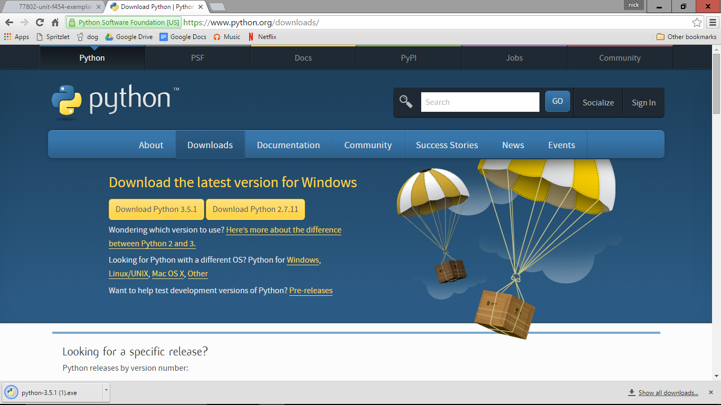

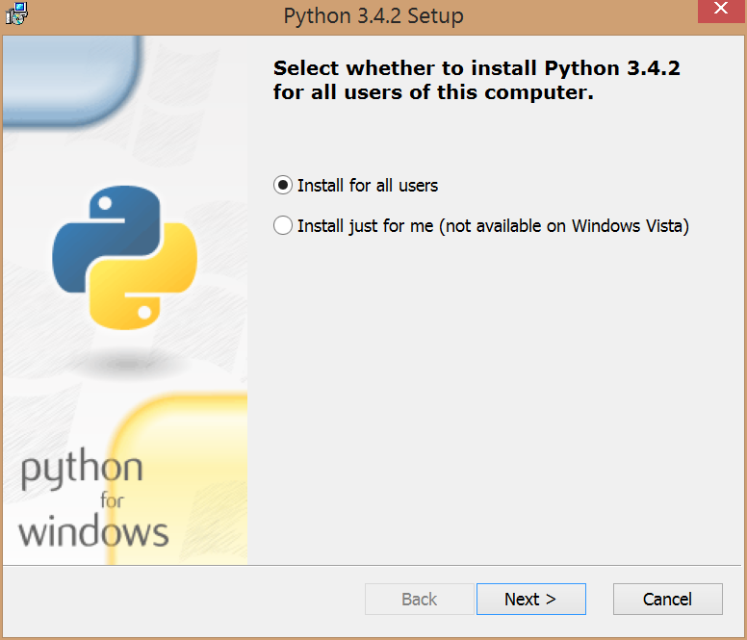Once it’s downloaded, open the .exe file. It should open an installation wizard. Click through the wizard and install Python to a location on your computer.

Once Python is installed, you’ll need to install Pygame. Go to <http://www.pygame.org/download.shtml> and find your relevant download for the version of Python you installed.

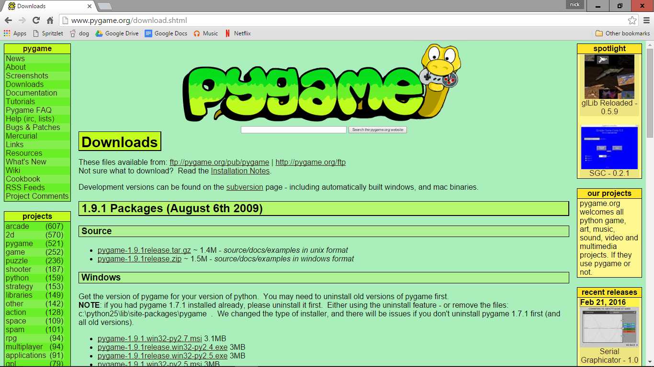

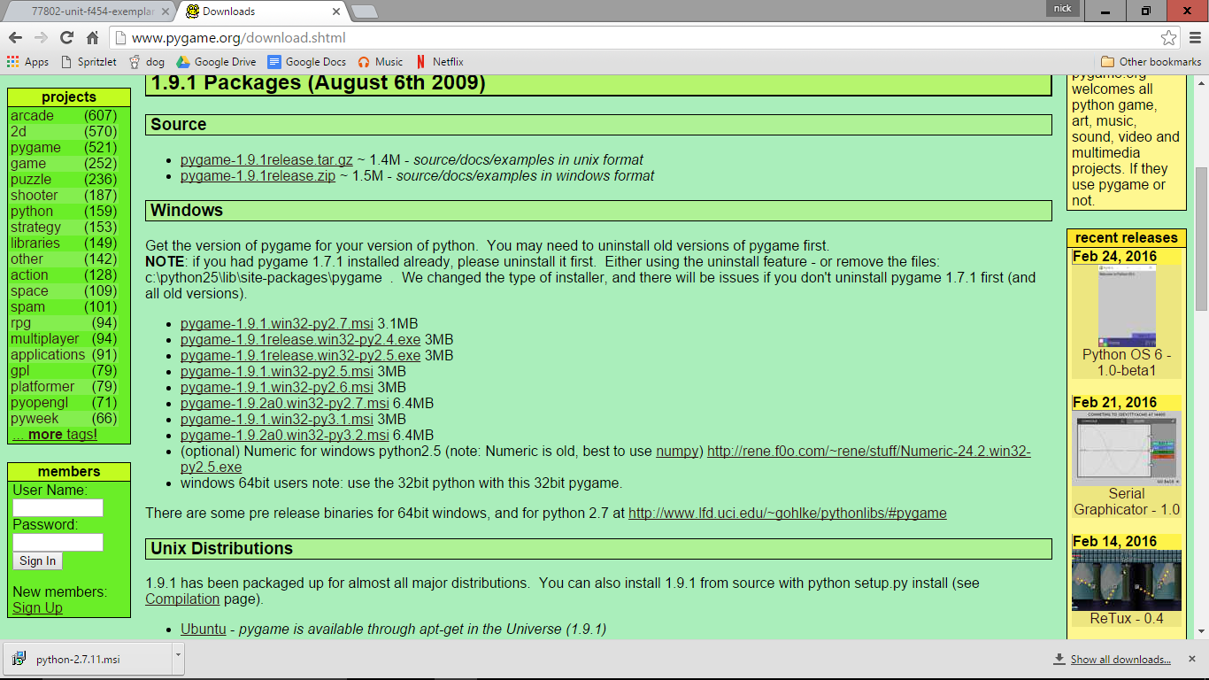Find the operating system that you are running in the list from the website. Once it has downloaded, it should open another wizard. Again, click through the wizard and install pygame at the relevant location.

This should be enough to run the game.

## Creating a Backup

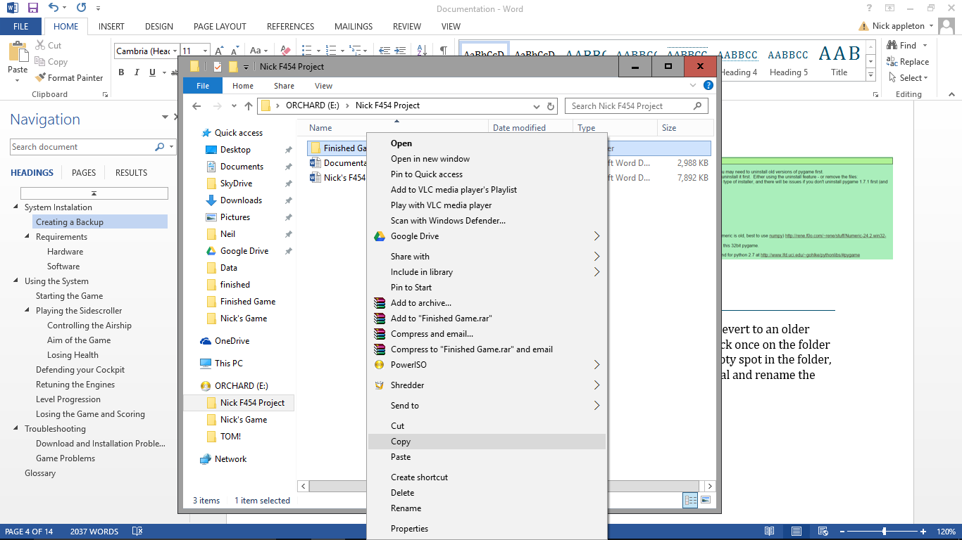A backup is useful in case something in the game goes wrong and you need to revert to an older version that works. To make a backup, go to the folder containing the game, click once on the folder that you want to back up, then right click. Select copy, then right click in an empty spot in the folder, and click on paste. Now if you need to revert to an older copy, delete the original and rename the backup to the original name.

## Requirements

### Software

* Requires a computer with both python and Pygame installed.
* Windows 98 or later
* Requires full game files to be installed on computer.

### Hardware

* Requires a standard English or American keyboard.
* Requires a monitor of at least 900x700 pixel resolution
* Requires 512MB of RAM
* 5MB of free space on hard drive

#### recommended

* 4GB of RAM
* 3.3GHz clock speed

# Using the System

## Starting the Game

First, locate the game folders on your computer. The folder should look like this:

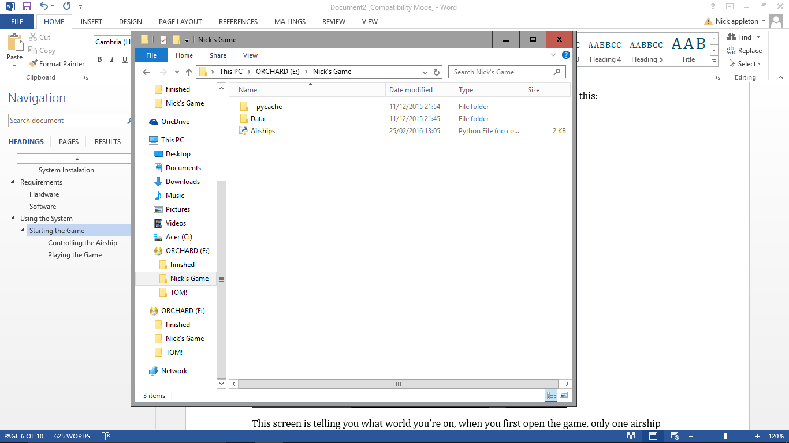

To start the game, simply double click on the ‘Airships’ file, this should open one window that should look like this:

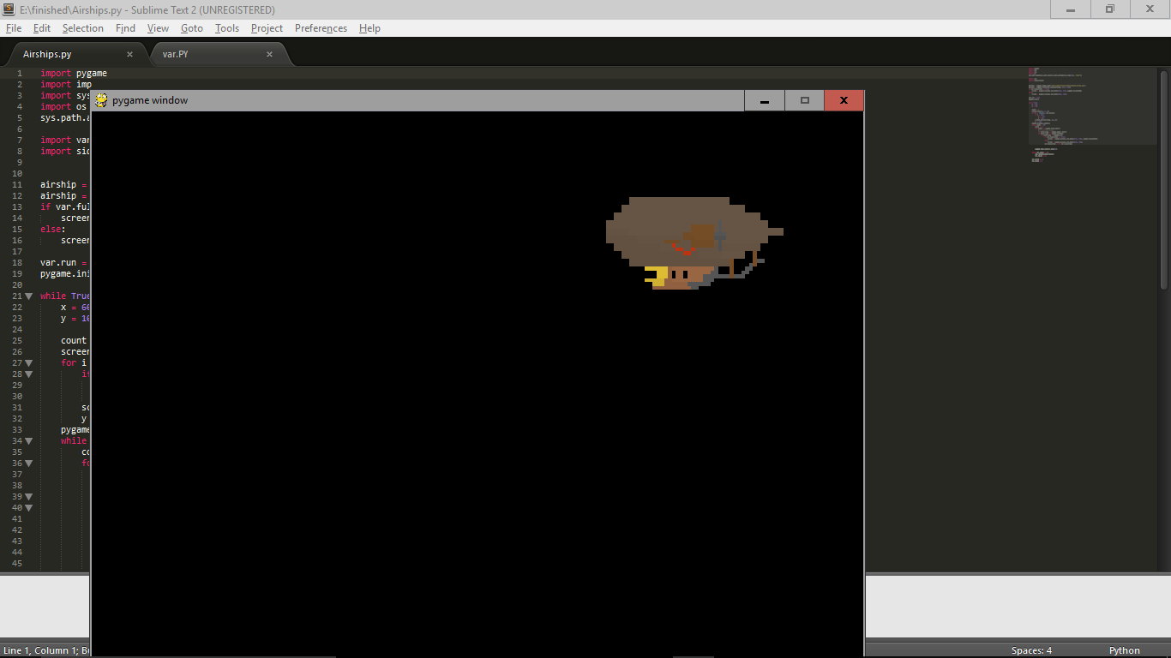

This is the game window, all of the game can be played in this window.

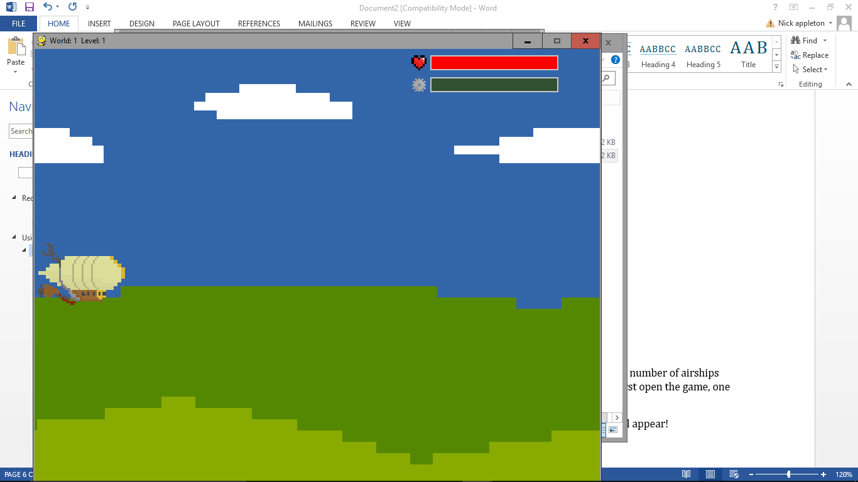The current screen you are seeing is the ‘New World’ screen, this displays a number of airships coinciding with the number of the world you are currently on. When you first open the game, one airship should be displayed.

After a few seconds, the New World screen should go, and the first level will appear!

At any point during the game you can press the 1 button to fullscreen the game for a more immersive experience.

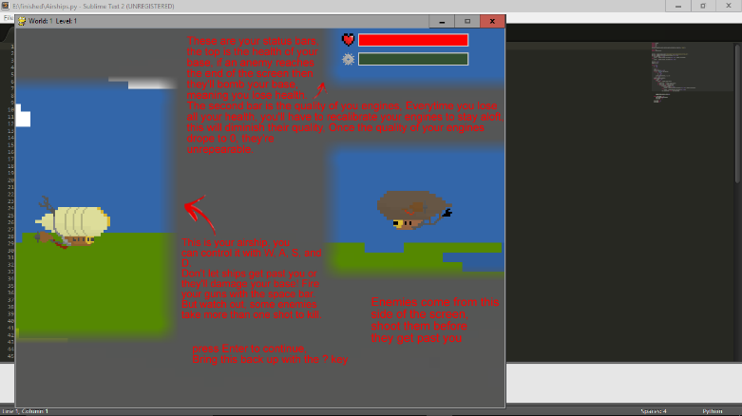After a couple more seconds, a tutorial will apperar on the screen, it is a good idea to read this to remind you of all of the controls.

## Playing the Sidescroller

### Controlling the Airship

Once you have passed the tutorial, you can use the W key to move your airship up the screen, S to move it down, A to move left, and D to move right. You can fire your cannons forwards by pressing the space key, or you can hold it down for rapid fire.

### Aim of the Game

The aim of the game is to get to the end of each level without losing all of your health. You lose health by letting enemies get past you and off the left hand side of the screen. To stop them, you need to shoot them down: line up your airship with the enemy and press space. Don’t worry about being hit, the enemies will fly behind you and not do damage to you (unless they get off the edge of the screen).

The end of the level

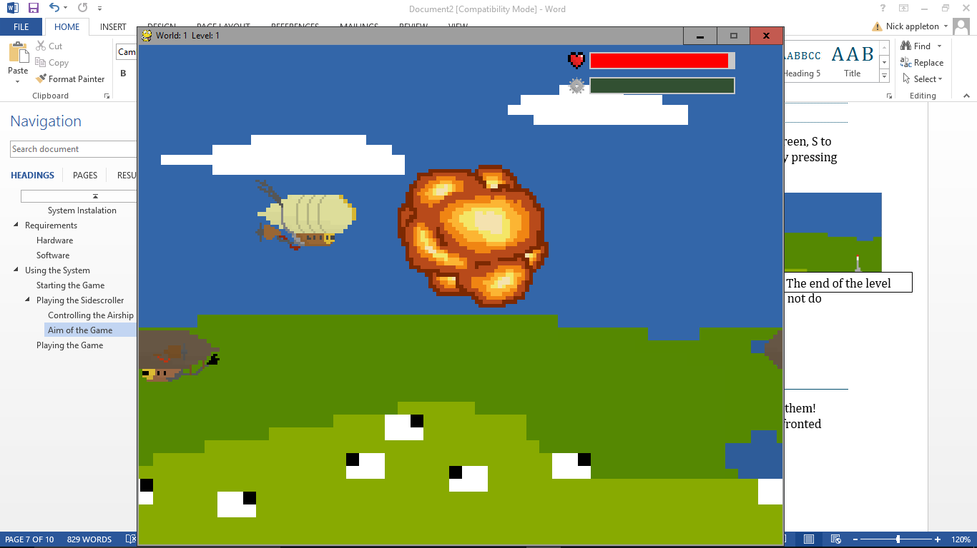

Bad

Good

### Losing Health

The two bars at the top of the screen represent your health and ‘engine quality’ respectively. You lose health by letting airships get to the end of the screen. If you run out of health, you will start to lose altitude. To fix this you’ll need to retune your engines (see ‘retuning the engines’). Every time you do this the quality of you engines will decrease slightly. If your engine quality bar reaches 0, then the next time you lose all of your health, your engines will be unrepairable. Your health bar is restored at the beginning of every level, but your engine quality is not.

## Defending your Cockpit

When you complete each level, a missile will be launched towards your airship. At this point you will go into a first person view of the airships cockpit.

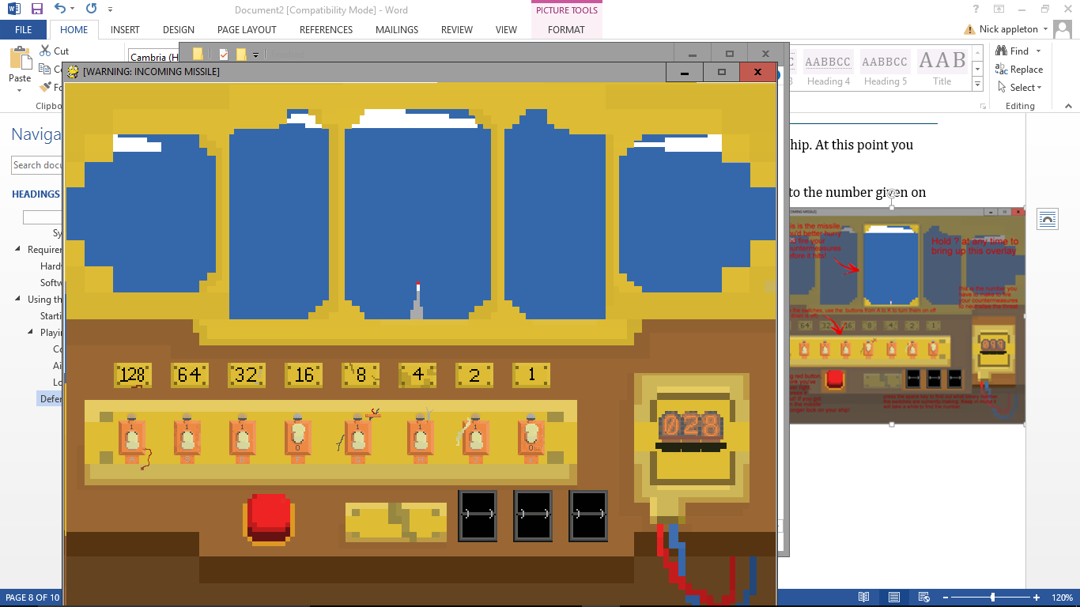

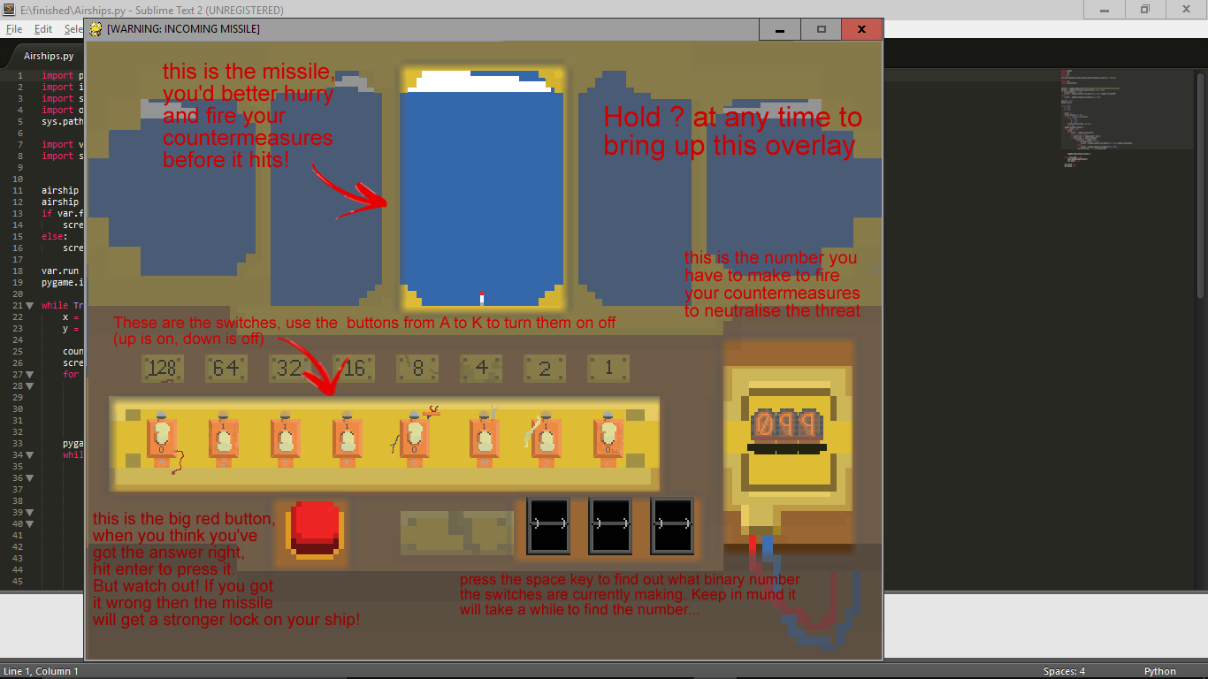To complete this section, you have to match the binary switches on the left to the number given on the right. To change the switches on the left of the dashboard, you use the keys A – K. you can also check what the binary number the switches are making with the current orientation at any time by pressing the spacebar, but watch out, it’s not instantanious. When you think you have the right answer, press the big red button at the bottom of the dashboard by pressing enter to check if it’s right. If it is, the game will end and you’ll go to the next level. If it’s not right then the missile will speed up briefly.

This section also has a tutorial to help you with the controls.

## Retuning the Engines

During the sidescroller, if you lose all of your health by letting too many enemies get past you then your airship will start losing altitude and you’ll have to re-calibrate the engines:

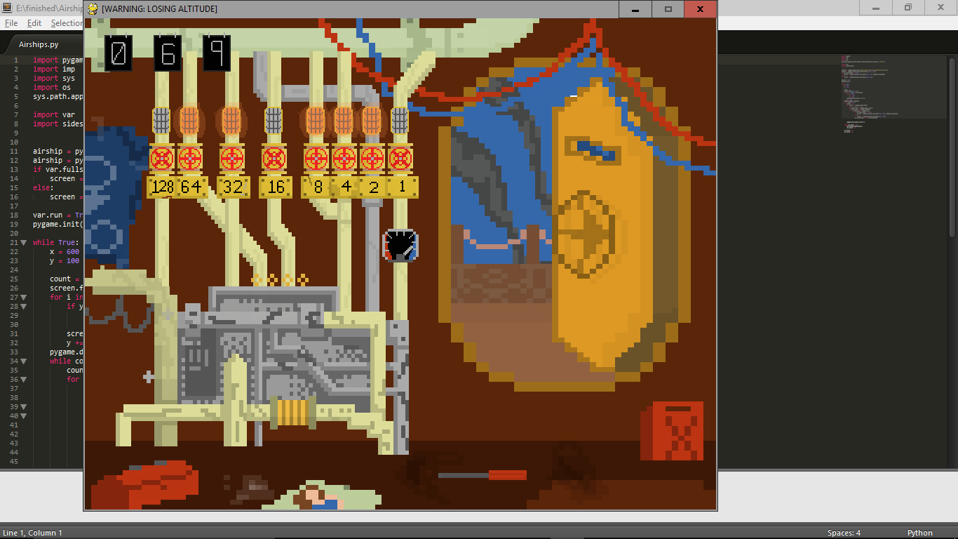

The principle of this part of the game is very similar to the missile section. You have to get the valves oriented to make the same value as the number hanging from the pipe in the top left of the screen. The valves state is represented as the lights above the valves themselves. The altimeter in the centre of the screen tells you how much time you have left until you crash into the ground. This time you cannot check what you currently have on the valves, but you still have to press enter to input your answer. If you get the answer right, then you’ll be transported to the sidescroller exactly where you left off, but your engine quality will decrease so be careful not to do it too many times!

## Level Progression

This game uses both levels and worlds to represent how far you are in the game. You start on world 1, level 1. When you get to the end of the sidescroller and successfully defend your cockpit, you’ll progress to world 1, level 2. If and when you complete level 5, you will progress to the next world, whereupon you’ll return to level 1 and have through progress through the levels again. However, the world number also acts as a multiplier to how many shots it takes to take down each enemy. This means that on world 2, it takes twice as many shots to take down each enemy than it does on world 1, world 3 takes three times as many, etc.

Starting world 3

## Losing the Game and Scoring

You can lose the game by either failing to retune your engine in time and crashing into the ground; not firing you countermeasures fast enough and being blown up by the missile; or by completely diminishing your engine quality and losing all your health. When you lose the game your airship will explode and the game will quit. If you want to continue playing, then you’ll have to do so from world 1 level 1. To score your game, you can simply remember the world and level you got to and challenge your friends to beat it. Alternatively you could remember how close the missile got to your airship, or even time how long it takes you to get to a certain level.

# Troubleshooting

Due to the nature of the game, it will not crash for any foreseeable reasons, this means that there are no error messages. However, there can still be some errors, this troubleshooting section will help you solve any that you encounter.

## Onscreen Help

If you get stuck at any point during the sidescroller or while defending your cockpit, you can press and hold the ? key to bring up the onscreen help. The same help will also appear on the first level of each section. The sidescroller reqires an input to dismiss, but the cockpit defence will be running while the overlay is present, and it’ll disappear after a bit. The onscreen help will look like this:

Sidecroller: Cockpit defence:



## Download and Installation Problems

**I can’t connect to the website.**

You require an internet connection to access both of the website, check that you’re connected to the internet and try again. Another cause of this could be that the websites themselves are having problems. To get around this, come back later and try again.

**The game files and/or Python and Pygame won’t save to my computer.**

Be sure that you have sufficient space to install all of the required files. The game itself requires 1MB of space.

**I’ve installed Pygame and Python, but the game still won’t run.**

Chances are Pygame hasn’t been installed properly. To check if it has, open you python IDLE, it should confront you with a window similar to this:

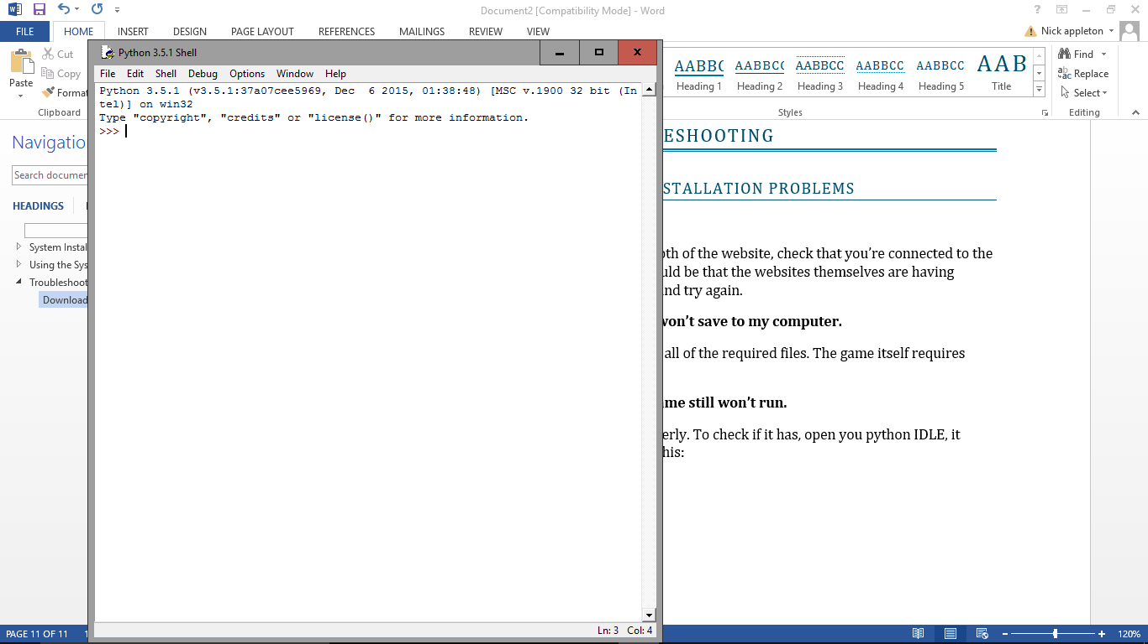

Type ‘import pygame’ without the quotation marks, if it displays an error like the one below, then pygame has been installed wrong.

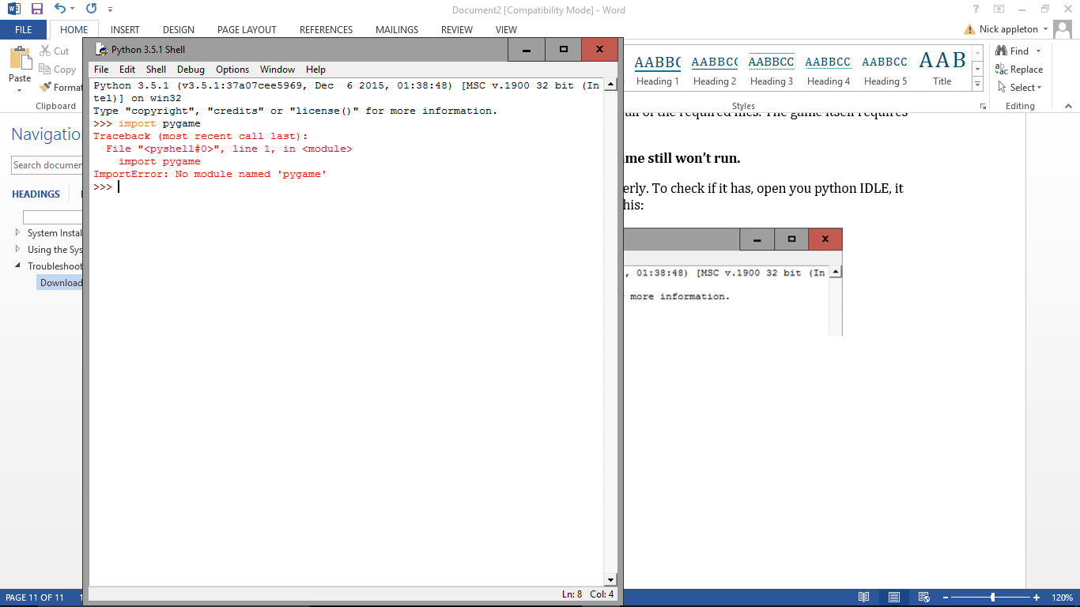

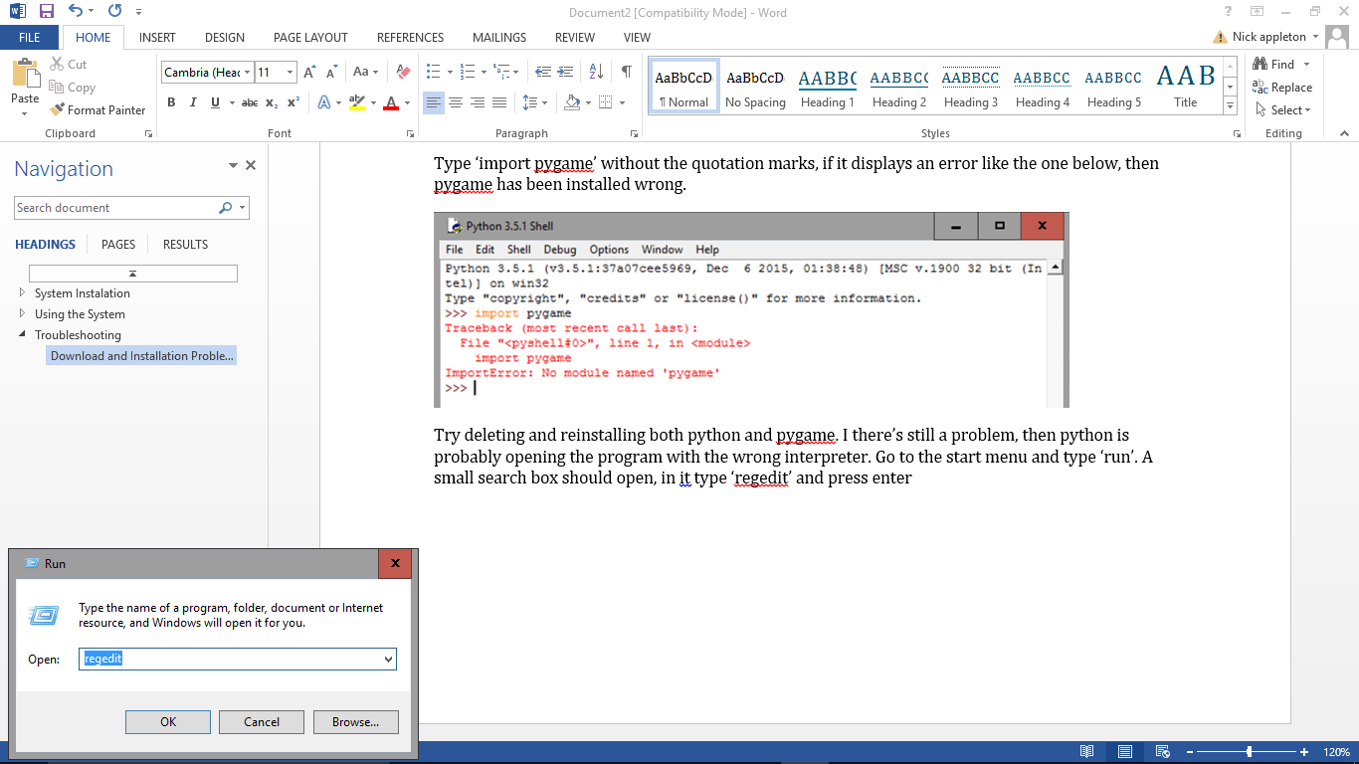Try deleting and reinstalling both python and pygame. I there’s still a problem, try right clicking on the airships file and pressing ‘open with IDLE’ press f5, if the game runs then python is probably opening the program with the wrong interpreter. Go to the start menu and type ‘run’. A small search box should open, in it type ‘regedit’ and press OK.

When the next window comes up, press yes. When you’re in the registry editor, find python.file in the list on the left. Use the drop down menu to navigat to shell, open, command and change the (Defaut) file to ["C:\Python32\python.exe" "%1" %*] (without the square brackets).

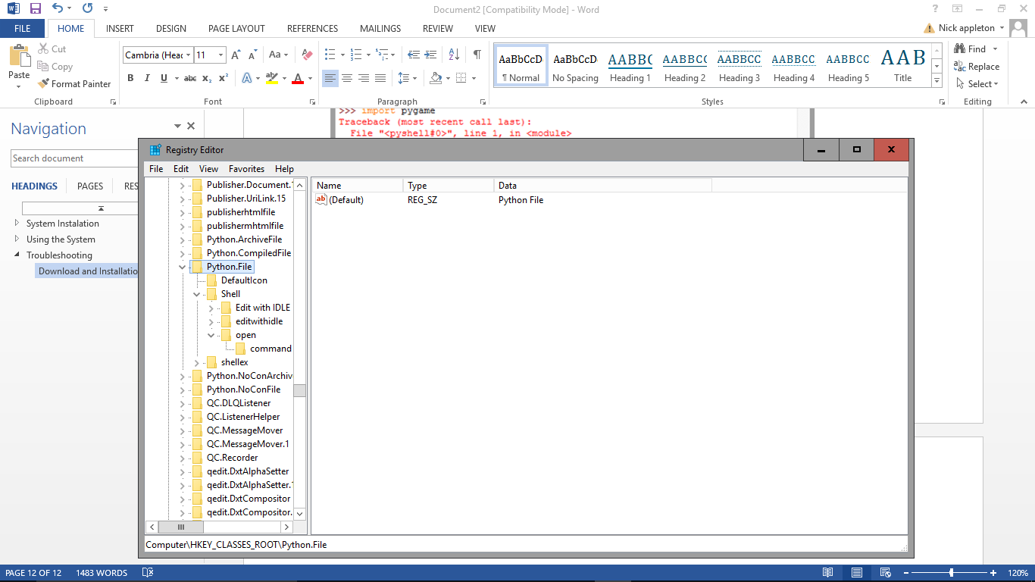

If running the game through IDLE doesn’t help, then pygame is probably still installed incorrectly.

## Game Problems

**When I go to back up my game there is no copy function.**

This is probably because you have not selected the folder. Make sure the folder you are backing up is highlighted by left clicking it.

**When I first open the game, it runs one of the quizzes immediately.**

This problem means that you have got a test version of the game and not the proper release version. To fix it you can: re-download the game; complete the quiz to start the main game; or you can go into the Data folder, right click on ‘var’ and click on ‘open with IDLE’. If anything says ‘True’ then change it to ‘False’ this should fix your problem.

**The game doesn’t start on world/level 2.**

This problem means that you have got a test version of the game and not the proper release version. To fix it you can either re-download the game or go into the Data folder, right click on ‘var’ and click on ‘open with IDLE’. The top 2 lines are the starting world and level, change them both to 1.

The var file should look like this:

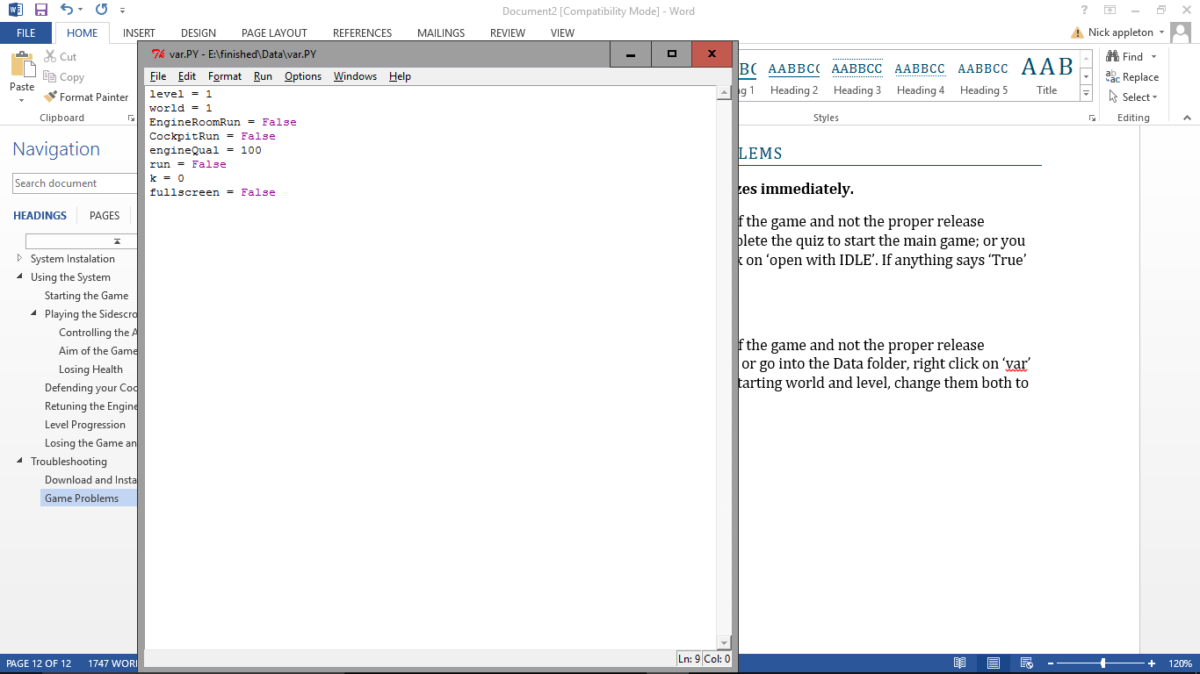

# Glossary

|  |  |
| --- | --- |
| **Term** | **Meaning** |
| Python | The language that the game is written in. If this is not installed on your computer, then it will not be able to read the code and you will be unable to play the game |
| PyGame | PyGame is a library routine that is required to make sure that Python can run the whole game. If PyGame is not installed, the game will not run. |
| Library Routine | This is an extension to a programming language that extends the functionality of the language, meaning that developers can do more complex instructions in a relatively simple manner. |
| Operating System | What your computer runs on, e.g. windows xp, windows 7, 8, 10, Mac OSX, Linux. |
| Installation wizard | A window that opens to help you install a piece of software onto your computer. They make it very easy and do almost all of the work for you. |
| Backup | A second copy of the game files located somewhere else in case the original ones are damaged or removed. |
| Fullscreen | The game will take up the entire screen rather than being constrained by a window. This can make the game run more smoothly as well as stop distractions and reducing the likelihood of accidentally changing windows. |
| MB | Stands for MegaBytes. This is a measure of how much memory your RAM has, and how fast your computer can run |
| RAM | Random Access Memory, what your computer uses to store the data that it’s processing with. |
| Resolution | The number of pixels a screen contains. The first number represents how many pixels there are horizontally, the second number is how many there are vertically. |
| Hard Drive | The device used for large, long-term storage on a computer, this is where the game will be kept. |
| Level | A number indicating how far through that world you are. Each world is split into 5 levels of increasing difficulty. |
| World | A larger form of levels, each time you complete the 5 levels, you will progress 1 world, which will be significantly harder than the last. |
| Altimeter | A device used for measuring altitude. In this game its purpose is to tell you how close to the ground you are, i.e. how much time you have left. |